%% Removing High-Frequency Noise from an ECG Signal

% This example shows how to lowpass filter an ECG signal that contains high frequency

% noise.

%%

% Create one period of an ECG signal. The |ecg| function creates an ECG signal

% of length 500. The |sgolayfilt| function smoothes the ECG signal using a

% Savitzky-Golay (polynomial) smoothing filter.

x = ecg(500).';

y = sgolayfilt(x,0,5);

[M,N] = size(y);

%%

% Initialize the time scope to view the noisy signal and the filtered

% signal.

Fs = 1000;

TS = timescope('SampleRate',Fs,...

'TimeSpanSource','Property',...

'TimeSpan',1.5,...

'ShowGrid',true,...

'NumInputPorts',2,...

'LayoutDimensions',[2 1]);

TS.ActiveDisplay = 1;

TS.YLimits = [-1,1];

TS.Title = 'Noisy Signal';

TS.ActiveDisplay = 2;

TS.YLimits = [-1,1];

TS.Title = 'Filtered Signal';

%%

% Design a minimum-order lowpass filter with a passband edge frequency of 200

% Hz and a stopband edge frequency of 400 Hz. The desired amplitude of the frequency

% response and the weights are specified in |A| and |D| vectors, respectively. Pass

% these specification vectors to the |firgr| function to design the filter

% coefficients. Pass these designed coefficients to the |dsp.FIRFilter|

% object.

Fpass = 200;

Fstop = 400;

Dpass = 0.05;

Dstop = 0.0001;

F = [0 Fpass Fstop Fs/2]/(Fs/2);

A = [1 1 0 0];

D = [Dpass Dstop];

b = firgr('minorder',F,A,D);

LP = dsp.FIRFilter('Numerator',b);

%%

% Design a minimum-order highpass filter with a stopband edge frequency of 200

% Hz and a passband edge frequency of 400 Hz. Design the filter using the

% |firgr| function. Pass these designed coefficients to the |dsp.FIRFilter|

% object.

Fstop = 200;

Fpass = 400;

Dstop = 0.0001;

Dpass = 0.05;

F = [0 Fstop Fpass Fs/2]/(Fs/2); % Frequency vector

A = [0 0 1 1]; % Amplitude vector

D = [Dstop Dpass]; % Deviation (ripple) vector

b = firgr('minord',F,A,D);

HP = dsp.FIRFilter('Numerator',b);

%%

% The noisy signal contains the smoothed ECG signal along with high

% frequency noise. The signal is filtered using a lowpass filter. View the

% noisy signal and the filtered signal using the time scope.

tic;

while toc < 30

x = .1 * randn(M,N);

highFreqNoise = HP(x);

noisySignal = y + highFreqNoise;

filteredSignal = LP(noisySignal);

TS(noisySignal,filteredSignal);

end

% Finalize

release(TS)

%%

% Copyright 2012 The MathWorks, Inc.

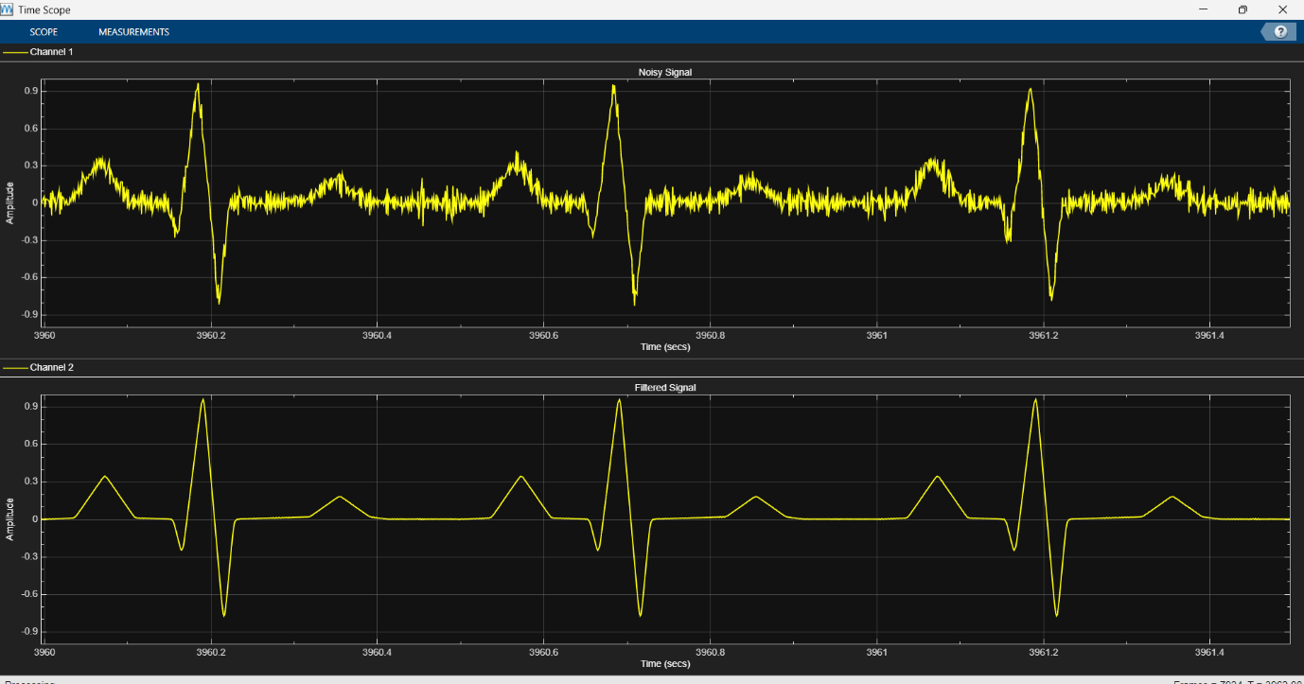

Ecg add function x = ecg(L)

a0 = [0, 1, 40, 1, 0, -34, 118, -99, 0, 2, 21, 2, 0, 0, 0];

d0 = [0, 27, 59, 91, 131, 141, 163, 185, 195, 275, 307, 339, 357, 390, 440];

a = a0 / max(a0);

d = round(d0 * L / d0(15));

d(15) = L;

for i = 1:14

m = d(i) : d(i+1) - 1;

slope = (a(i+1) - a(i)) / (d(i+1) - d(i));

x(m+1) = a(i) + slope * (m - d(i)); %#ok<AGROW>

end

--------------------------------------------------------------------------------------------------------------------------------------

%% Removing High-Frequency Noise from an ECG Signal

% This example shows how to lowpass filter an ECG signal that contains high frequency

% noise.

%%

% Create one period of an ECG signal. The |ecg| function creates an ECG signal

% of length 500. The |sgolayfilt| function smoothes the ECG signal using a

% Savitzky-Golay (polynomial) smoothing filter.

x = load('C:\Users\HP\Downloads\archive (1)\ptbdb_normal.csv');

x = x(:, 1:100); % Selecting the first 100 columns

y = sgolayfilt(x, 0, 5);

[M, N] = size(y);

%%

% Initialize the time scope to view the noisy signal and the filtered

% signal.

Fs = 1000;

TS = timescope('SampleRate',Fs,...

'TimeSpanSource','Property',...

'TimeSpan',1.5,...

'ShowGrid',true,...

'NumInputPorts',2,...

'LayoutDimensions',[2 1]);

TS.ActiveDisplay = 1;

TS.YLimits = [-1,1];

TS.Title = 'Noisy Signal';

TS.ActiveDisplay = 2;

TS.YLimits = [-1,1];

TS.Title = 'Filtered Signal';

%%

% Design a minimum-order lowpass filter with a passband edge frequency of 200

% Hz and a stopband edge frequency of 400 Hz. The desired amplitude of the frequency

% response and the weights are specified in |A| and |D| vectors, respectively. Pass

% these specification vectors to the |firgr| function to design the filter

% coefficients. Pass these designed coefficients to the |dsp.FIRFilter|

% object.

Fpass = 200;

Fstop = 400;

Dpass = 0.05;

Dstop = 0.0001;

F = [0 Fpass Fstop Fs/2]/(Fs/2);

A = [1 1 0 0];

D = [Dpass Dstop];

b = firgr('minorder',F,A,D);

LP = dsp.FIRFilter('Numerator',b);

%%

% Design a minimum-order highpass filter with a stopband edge frequency of 200

% Hz and a passband edge frequency of 400 Hz. Design the filter using the

% |firgr| function. Pass these designed coefficients to the |dsp.FIRFilter|

% object.

Fstop = 200;

Fpass = 400;

Dstop = 0.0001;

Dpass = 0.05;

F = [0 Fstop Fpass Fs/2]/(Fs/2); % Frequency vector

A = [0 0 1 1]; % Amplitude vector

D = [Dstop Dpass]; % Deviation (ripple) vector

b = firgr('minord',F,A,D);

HP = dsp.FIRFilter('Numerator',b);

%%

% The noisy signal contains the smoothed ECG signal along with high

% frequency noise. The signal is filtered using a lowpass filter. View the

% noisy signal and the filtered signal using the time scope.

tic;

for i = 1:min(N, 100) % Ensure a maximum of 100 channels

noisySignal = y(:, i) + HP(x(:, i));

filteredSignal = LP(noisySignal);

TS(noisySignal, filteredSignal);

end

% Finalize

release(TS)

%%

% Copyright 2012 The MathWorks, Inc.

